Soulslike game in Unity – Daniel Trandafir

**Sprint 2 realisation**

Table of Contents

**Introduction** 1

**I.** **Save Game Manager** 1

**1.** **Character Save Data** 2

**2.** **World Save Game Manager** 2

**3.** **Save File Data Writer** 5

**II.** **Project Maintenance** 5

**III.** **Jumping & Character Effects** 6

**1.** **Jumping** 6

**2.** **Character Effects** 6

# **Introduction**

The purpose of this document is to provide a more detailed analysis of the progress I made with my personal project during the second sprint. In this phase of my project, I focused mostly on designing a save game system, allowing the player to create and load save files of their character. Alongside this, I did a lot of maintenance work and bug fixing, which is an essential part of game development, especially as the game begins to take shape. Thus, in this report I will go into more depth into these features I implemented and showcase them visually, as well as go over what my next steps are for the following sprints.

# **Save Game Manager**

Being able to save your progress in a game is a concept almost as old as gaming itself. Soulslike games have had this feature ever since their inception, starting with Demon’s Souls in 2009. Not only is my game expected to have such a system due to its inherent characteristics as an Action RPG, but creating a save game mechanic is an extremely valuable learning experience for me as a beginner game developer and is the main reason why I chose to implement it so early. As for most of the other mechanics I’ve implemented, I have used Sebastian Graves’ [“How to create *ELDEN RING* in Unity”](https://www.youtube.com/watch?v=oB9-kns4m94&list=PLD_vBJjpCwJvP9F9CeDRiLs08a3ldTpW5) tutorial series as my main reference and learning source.

The structure of the system I designed is as follows:

1. **Character Save Data:** this is a serialized class that contains data about the player character, such as their position, health, stamina etc. and can then be converted into a format that can be saved and stored later(in my case, JSON).

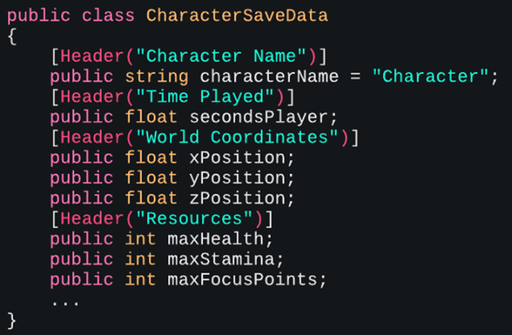

Image 01: CharacterSaveData class

1. **World Save Game Manager:** this prefab contains the script that handles the main SaveGame() and LoadGame() methods that enable player character data to be stored / loaded. For now, this is done by checking a boolean in the Inspector window that tells the manager to save the game. In the future, this will be moved to the player’s UI. In addition, the script also handles creating new player character data and new character slots. It is the foundation of the entire save game system. For the purposes of this report, I will only go into depth into the “Save Game” and “Load Game” mechanics.

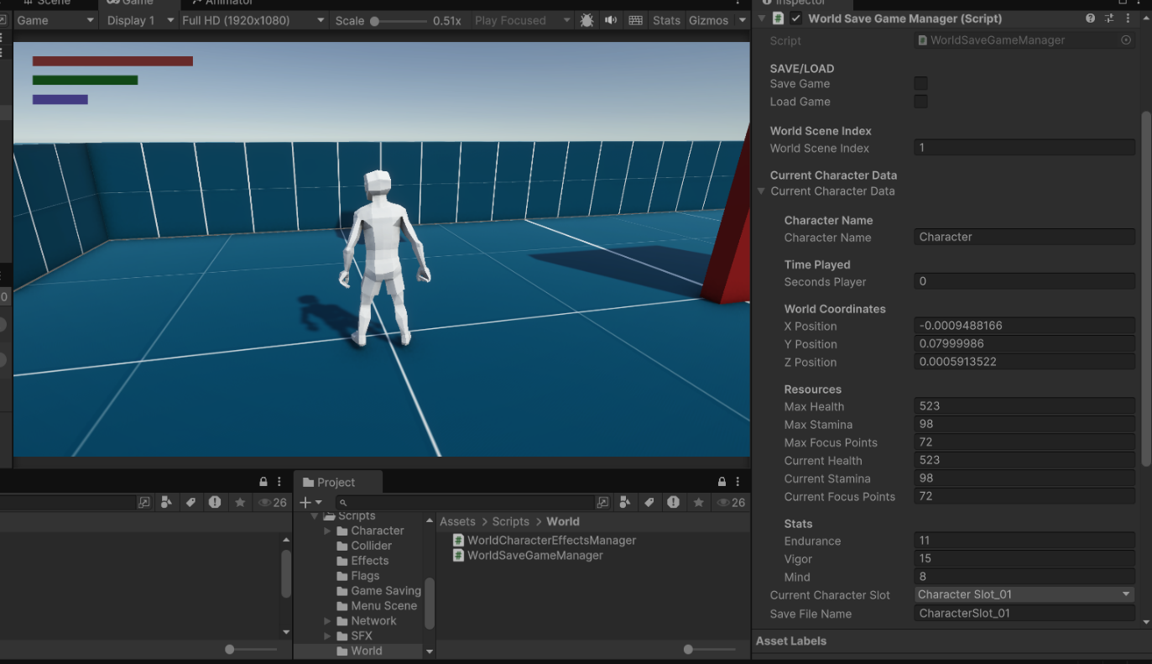

Image 02: The World Save Game Manager Inspector window in the World Scene.

* 1. **SaveGame() method:** Firstly, this method checks if the player character attempting to save the game is a host, not a client. A client should not be able to save their game on another server. Then it calls the SaveFileDataWriter class multiple times to create the JSON file containing the character data. Finally, it calls the SavePlayerData() method inside the PlayerManager class and assigns to all the CharacterSaveData variables their corresponding NetworkVariable values.

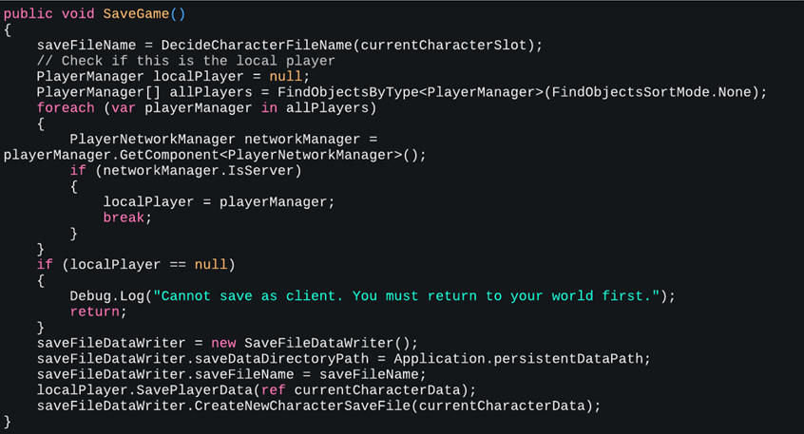

Image 02: The SaveGame() method

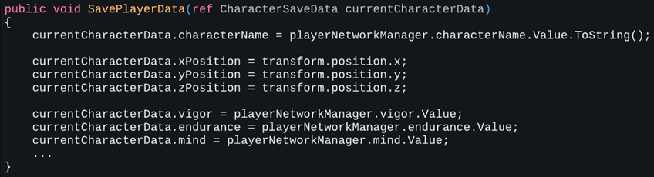

Image 03: The SavePlayerData() method

* 1. **LoadGame() method:** Very similar to the SaveGame() method, except that instead of creating a new file, it looks for a JSON file with the specified name and loads the World Scene with the player. In the Coroutine, the player’s data is loaded using the LoadPlayerData() method that references a variable of type CharacterSaveData.

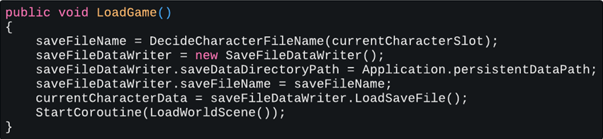

Image 04: The LoadGame() method

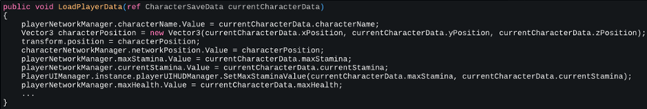

Image 05: The LoadPlayerData() method

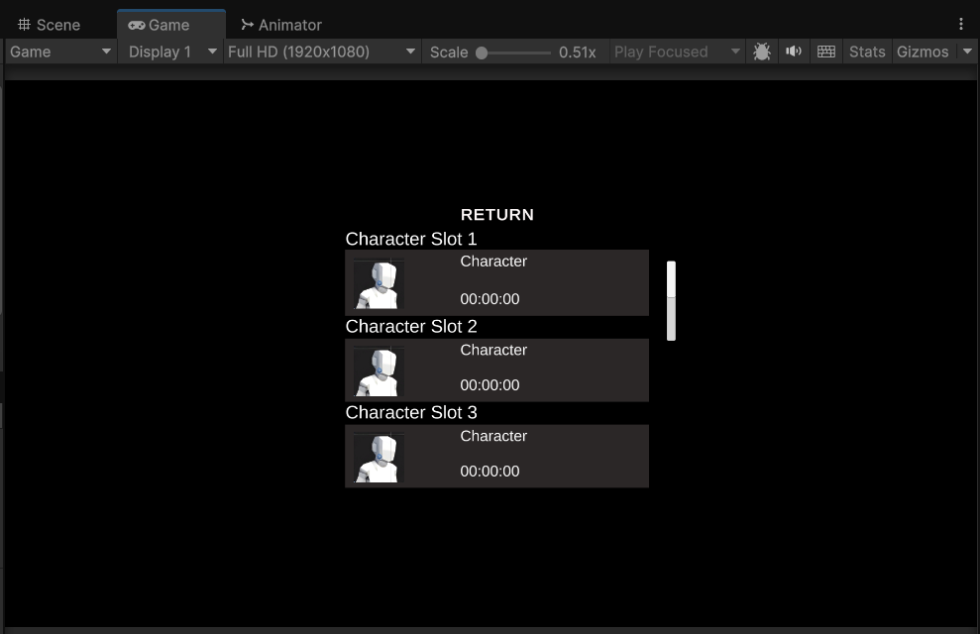

Image 06: The Title Screen Load Menu

## **Save File Data Writer**

This is a very basic class that handles reading and writing data to files, as well as deleting files or checking to see if they already exist.

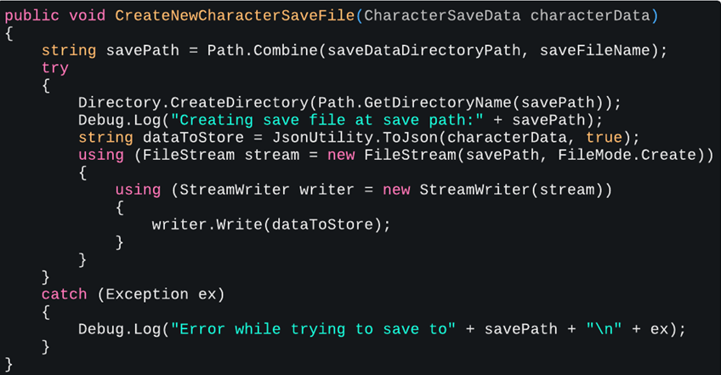

Image 07: Creating save files for player data

# **Project Maintenance**

Due to my inexperience as a game developer, a lot of bugs had started piling up in older classes and I was facing many compatibility issues trying to use that old code with the new features I implemented. I created a form of a debugging log using Microsoft OneNote to keep track of the changes and fixes I added.

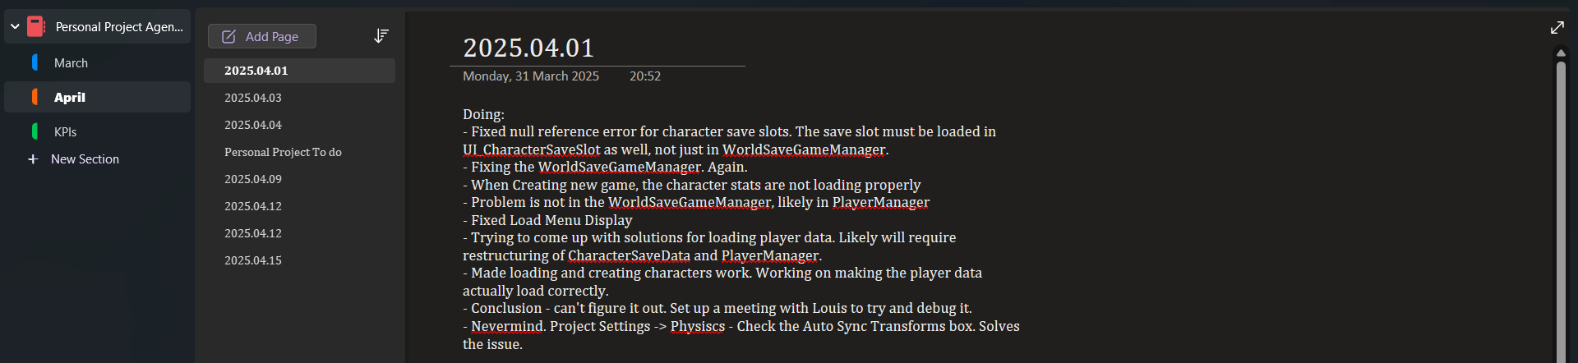

Image 08: My debugging log in OneNote

The issues I faced arose mostly because of my still somewhat basic understanding of how scripting in Unity works. Even though it is a tiring and annoying process at times, it always brought about a greater understanding of the code and its underlying logic.

For this process, I heavily used AI tools like ChatGPT and Claude, as debugging is one of the only processes I find them especially good at when it comes to coding.

# **Jumping & Character Effects**

During this sprint, I also created the functionality to let the player jump and take damage by applying an effect to the character. As for all of my animations so far, the jumping animation was part of an animation pack that I got from the Unity Asset Store.

## **Jumping**

* For jumping, I attempted to imitate the feel of the jump in ELDEN RING, where you can rotate in midair and gain extra speed if jumping while running. I managed to add these features, but I am not fully satisfied with the way it feels and will likely adjust the code and variables in the future.
* All the code for performing the jump is located in the Player Locomotion Manager class



Video 01: The player character jumping

## **Character Effects**

* I created the framework for the system that will hanlde applying character effects (i.e. taking damage of various types, getting staggered etc.). I created a new prefab manager, the *World Character Effects Manager,* multiple scriptable objects for my effects, a *Damage Collider* class that will be attached to any object that deals damage on contact with the player, and the *Character/Player Effects Manager* to process these effects.

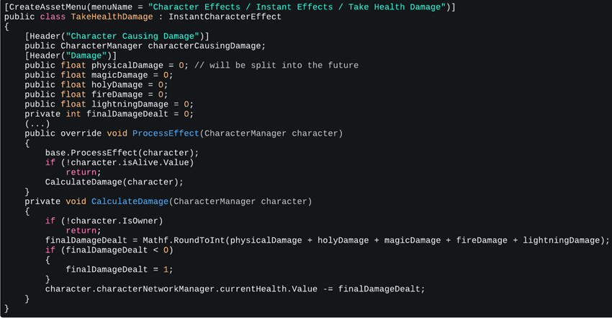

Image 09: *TakeHealthDamage* Scriptable Object class

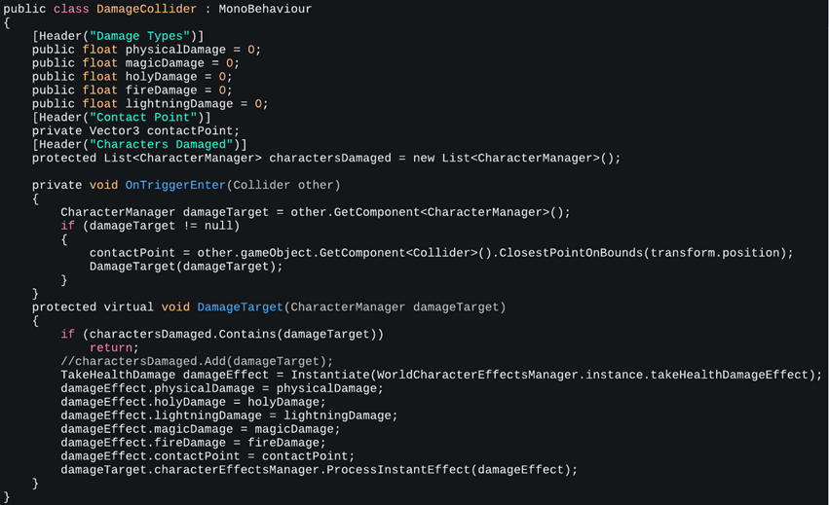

Image 10: *DamageCollider* class



Video 02: Taking Damage and Death Animation

# Conclusion

Overall, I belive my progress has been steady and that I have stayed consistent in regards to the amount of work I do, but also its quality. However, based on feedback I received from talking to a game expert, I will have to learn how to design games as well, not just implement features: ”[...] you are tinkering with Unity. I would like to see you focus more on *game design*, not only *game creation*. ” Nevertheless, I am still steadily achieving the objectives I set out in the Project Plan. My next steps are to do more research into game design and think more about the direction my game is heading towards, as well as implement attacking animations and possibly an enemy type, on the technical side.